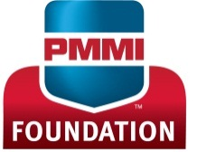
SCHOLARSHIP APPLICATION FOR 2018
Bill Zito Scholarship

Applicant Information
Name: |  | Date:
Email Address:
Street Address: |  | Phone:
City: | State: | ZIP Code:
PROGRAM INFORMATION
Name of School:
Contact Person: | Email:
Street Address: | Phone:
City: | State: | ZIP Code:
Major: | Anticipated Graduation Date:
FACULTY RECOMMENDATION
Please attach a letter of recommendation from a school faculty member, and have them sign below:

I recommend this individual for the Bill Zito Scholarship:
Print Name: | Phone:
Signature: | Title:
STUDENT SIGNATURE
Print Name:
Signature:
ATTACHMENTS
Please attach the following:
- 500-1,000 word essay describing your interest in the packaging field and your career goals
- Copy of transcripts indicating a GPA of 3.0 or higher
- Letter of recommendation from a school faculty member

