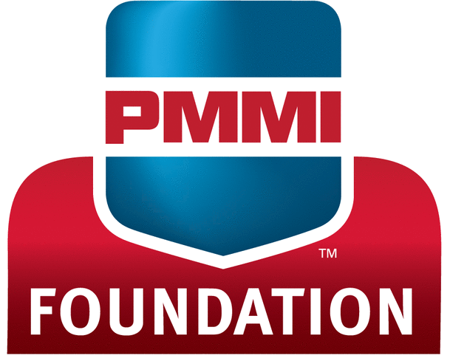
Tuition Reimbursement Application
Applicant Information
Name: |  |  | Date:
Title: | Company:
Email Address:
Street Address: |  |  | Phone:
City: |  | State: | ZIP Code:
PROGRAM INFORMATION
Name of School/Training Organization:
Street Address: |  | Phone:
City: |  | State: | ZIP Code:
Name of course/seminar: |  |  | Cost of Tuition: $
Course Start Date: |  | Course Completion Date:
Purpose for taking course/seminar:

Applicant must obtain both of the following signatures:
Supervisor Recommendation
As the applicant’s immediate supervisor, I recommend this person for a PMMI Tuition Reimbursement and verify that he/she is an employee of our company and that the course he/she is taking is job-related.
Print Name: |  | Phone:
Signature: |  | Title:
PMMI Executive Representative Support
As the PMMI executive representative for this company, I support this person’s application for a PMMI Tuition Reimbursement based on his/her supervisor’s recommendation.
I understand reimbursement check will be made out to the employee, not the company.
Print Name: |  | Phone:
Signature: |  | Title:
SUBMISSION INSTRUCTIONS
- All of the following must be included: Your completed application, payment receipt, and copy of final grade report issued by the course provider indicating a grade “B” or higher, or (for training events) a certificate of completion, or (for non-certificate training) proof of attendance.
- By Email: Email PDF of application & accompanying documentation to jdavis@pmmi.org.
- By Regular Mail: Mail to: Jill Davis • Education & Workforce Development Department PMMI • 11911 Freedom Drive, Suite 600, Reston, VA 20190.

